**1. What is a Macro? How is it useful in excel or in your daily work?**

**Ans:**

Macro in Excel is a programming language used to automate tasks in Microsoft Excel. It helps users to automate repetitive tasks and create custom applications within Excel. It is a powerful tool that helps users to create complex calculations and automate tasks quickly and easily. Suppose that every month, you create a report for your accounting manager. You want to format the names of the customers with overdue accounts in red and apply bold formatting. You can create and then run a macro that quickly applies these formatting changes to the cells you select.

**There are numerous advantages to using a macro.**

1. They reduce human error. This is helpful for processes that are involved and require a lot of steps to accomplish a single objective.
2. They streamline high-level reporting functions. Not only do these macros reduce the chances of human error, they also promote efficiency and help improve business processes.
3. Using Excel Macros boosts productivity, especially when used to handle redundant tasks.

**2. What is VBA? Write its full form and briefly explain why VBA is used in excel?**

**Ans:**

Visual Basic for Applications (VBA) is part of Microsoft Corporation's (NASDAQ: MSFT) legacy software Visual Basic. VBA is used to write programs for the Windows operating system and runs as an internal programming language in Microsoft Office (MS Office, Office) applications such as Access, Excel, PowerPoint, Publisher, Word, and Visio. VBA allows users to customize beyond what is normally available with MS Office host applications.

**VBA in Excel:**

All Office suite programs share common programming languages, and each have the capability of integrating VBA code to enhance the program. Due to the repetitive nature of spreadsheets, data analytics, and organizing data, VBA has been a natural fit with Excel more so than other Office suite programs. The root of the relationship between VBA and Excel is often tied to the use of macros. To run a macro in Excel, you use VBA, though you can use VBA for non-macro activities as well.

**3. How do you record a macro? Write detailed steps to create a macro to automatically make the following table in bold and to create borders for it in excel.**

hi 78

hello 69

ineuron 45

**Ans:**

let's record a macro that applies some formatting to table in above data. For this, do the following:

1. Select one or more cells that you want to format.

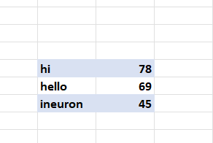 2. On the Developer tab or Status bar, click Record Macro. 3. In the Record Macro dialog box, configure the following settings: 4. Name the macro Table Formatting. 5. Place the cursor in the Shortcut key box, and press Ctrl + k keys simultaneously. 6. Choose to store the macro in this workbook 7. For Description, use the following text explaining what the macro does: Makes table bold, and creates borders 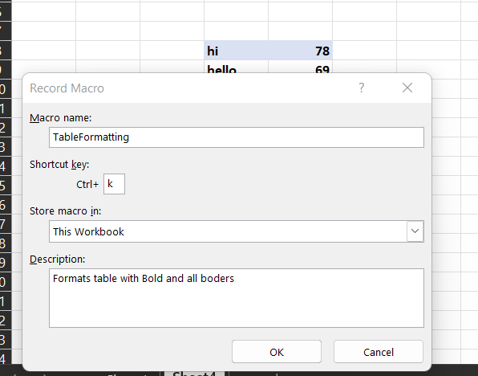 8. Click OK to start recording. 9. Format the pre-selected cells the way you want. 10. Click Stop Recording on either the Developer tab or the Status bar. 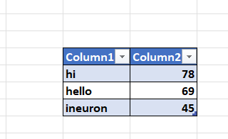 That's it! Your macro has been recorded. Now, you can select any range of Table, press the assigned shortcut ( Ctrl + K), and your custom formatting will be immediately applied to the selected cells.

**4. What do you mean when we say VBA Editor?**

**Ans:**

Visual Basic Editor is a separate application that is a part of Excel and opens whenever you open an Excel workbook. By default, it’s hidden and to access it, you need to activate it.

VB Editor is the place where you keep the VB code.

There are multiple ways you get the code in the VB Editor:

1. When you record a macro, it automatically creates a new module in the VB Editor and inserts the code in that module.
2. You can manually type VB code in the VB editor.
3. You can copy a code from some other workbook or from the internet and paste it in the VB Editor.

\***Opening the VB Editor**\* There are various ways to open the Visual Basic Editor in Excel:

1. Using a Keyboard Shortcut (easiest and fastest)
2. Using the Developer Tab.
3. Using the Worksheet Tabs.

Let’s go through each of these quickly.

* Keyboard Shortcut to Open the Visual Basic Editor

The easiest way to open the Visual Basic editor is to use the keyboard shortcut – **ALT + F11** (hold the ALT key and press the F11 key). 

* To open the Visual Basic Editor from the ribbon:

1. Click the Developer tab.
2. In the Code group, click on Visual Basic.

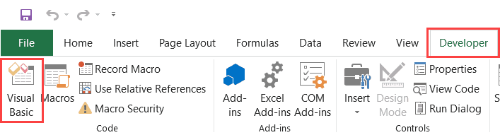

* Using the Worksheet Tab

1. This is a less used method to open the Vb Editor.
2. Go to any of the worksheet tabs, right-click, and select ‘View Code’.

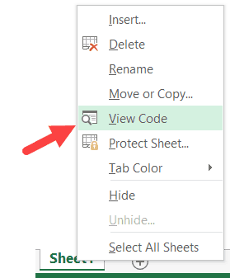

This is useful when you want to write code that works only for a specific worksheet.

**5. Briefly describe the interface of a VBA editor? What is properties window? And what is watch window? How do you display these windows?**

**Ans:**

The VBA Editor interface consists of several windows and panes that are used for writing, debugging, and managing VBA code. The main windows of the VBA Editor are as follows:

1. Code Editor: This is the main window where users write VBA code. It includes features such as syntax highlighting, code completion, and debugging tools.
2. Project Explorer: This window displays a hierarchical view of the current VBA project, including all the modules, forms, and other components.
3. Properties Window: This window displays the properties of the selected object or control, such as its name, size, font, color, etc.
4. Watch Window: This window allows users to monitor the value of a specific variable, expression, or object while the program is running.

-To display the Properties Window or the Watch Window in the VBA Editor, follow these steps:

* Open the VBA Editor by pressing Alt+F11 or by going to the "Developer" tab and clicking on "Visual Basic" in the "Code" group.
* To display the Properties Window, go to the "View" menu and select "Properties Window" or press F4.
* To display the Watch Window, go to the "View" menu and select "Watch Window" or press Ctrl+Shift+W.
* The Properties Window and Watch Window can also be docked or undocked by dragging their title bars to different positions within the VBA Editor.

**6. What is an immediate Window and what is it used for?**

**Ans:**

The Immediate Window is useful for testing and debugging VBA code because it allows users to quickly execute code and view the results in real-time. Users can enter one or more VBA statements in the Immediate Window and press Enter to execute them. The results of the statements are displayed in the Immediate Window. The Immediate Window can also be used to inspect the values of variables and expressions at different stages of the program execution. Users can use the Debug. Print statement to output the values of variables or expressions to the Immediate Window.

* To open the Immediate Window in the VBA Editor, follow these steps:

1. Open the VBA Editor by pressing Alt+F11 or by going to the "Developer" tab and clicking on "Visual Basic" in the "Code" group.
2. Go to the "View" menu and select "Immediate Window" or press Ctrl+G.
3. The Immediate Window will open at the bottom of the VBA Editor, where you can enter and execute VBA statements.

Overall, the Immediate Window is a powerful tool that can help users debug and test VBA code more efficiently by providing a real-time environment to execute statements and evaluate expressions.